**Database 3 Lab**

**DBMS install and config comparison**

Learning outcome(s): at the end of this lab you should be able to

* Perform installation & configuration of Ingres RDBMS
* Compare Ingres and MySQL DBMS install & config

Instructions:

* At each stage of the installation process **take note of the similarities and differences** between this product and MySql. Note a ‘compare & contrast’ style exam question.
* Take particular note for the differences in SQL, recovery and utilities.

You may need to research aspects of the installation. Ingres is a Actian (Computer Associates) product.

**You should take note of**

Installation for more mission critical database applications by having options for:

* Cluster for high availability,
* Dual Log (recovery),
* Multiple Instances,
* Data management for specifying different locations with a recommendation for different devices.

Log size? Contrast with MySql._____________________________________

Specification of Strict SQL mode (92). What is Strict mode? What does 92 refer to?

Ease of use for administrators with utilities and performance monitors included as basic package. Note, performance monitor only available with Enterprise Edition of MySql 5 at cost.

Concurrency: Number of simultaneous users/connections.

If aspects of the system are not specified at install time, you should expect that they must be configurable during normal (day to day) operations.

Ingres 10 is the latest version of the Ingres Database, an enterprise open source database. The release contains a number of major enhancements that will minimize application development time when migrating applications from other databases to Ingres. New features include support for multi-version concurrency control (MVCC), high-performing batched statement execution, full scalar subquery support, support for identifiers up to 256 characters long, and column-level data encryption. The release supports an automated, seamless migration from earlier versions of Ingres

On the desktop you should see a folder for Ingres 10.1, Use Windows Explorer to locate the Setup.exe file for Ingres in that folder on the Local Disk (C:)

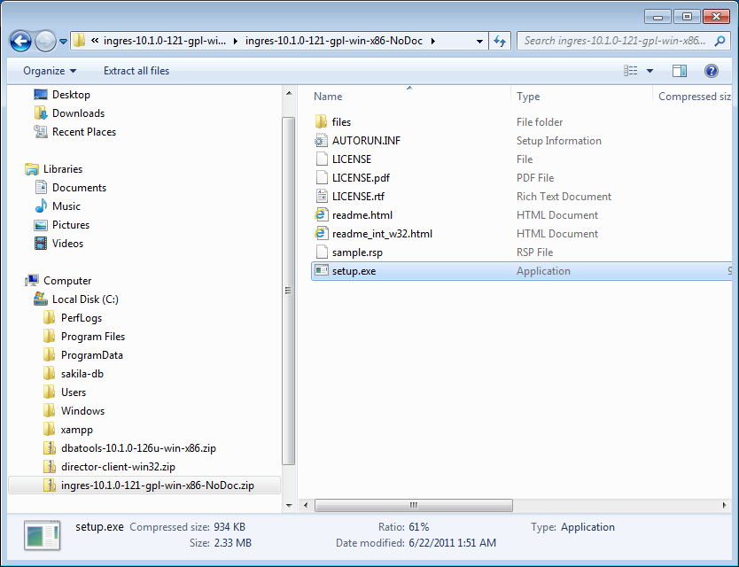

**Run the setup.exe program**

**Accept the terms and conditions**

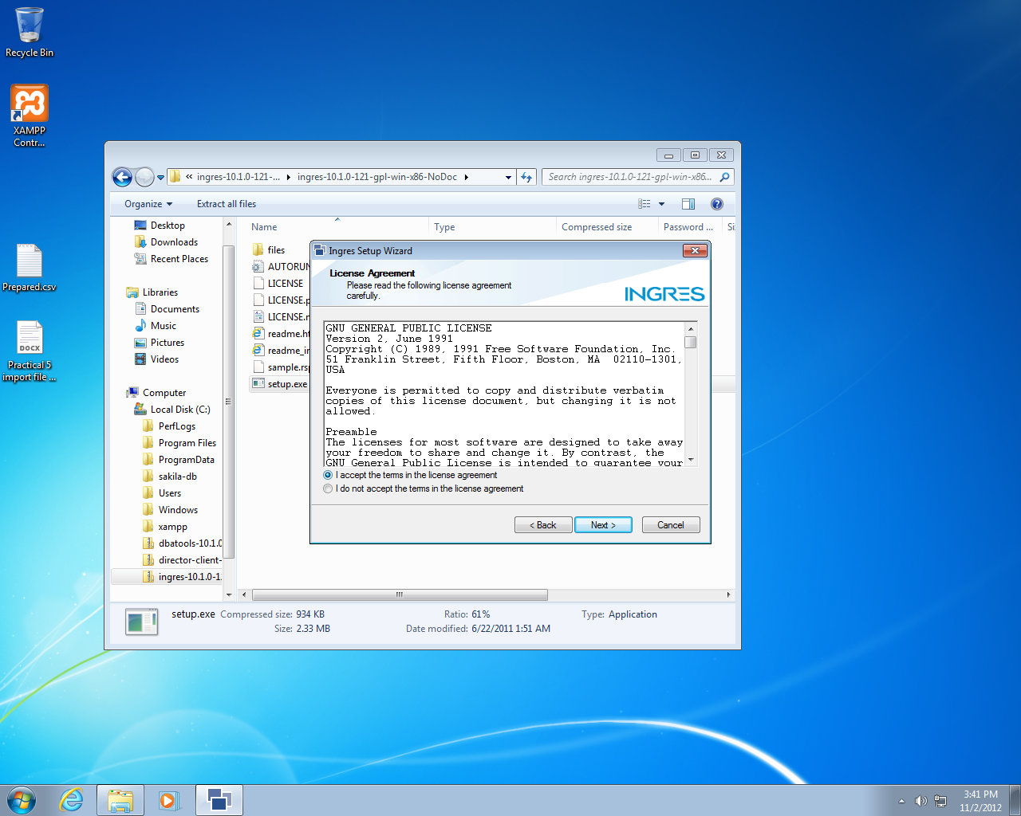

In the Ingres Configuration window (next page), note the confirguration types. The descriptions seem to indicate that the main factor that defines the different configuration types is:

**Concurrency i.e. number of connections, level of correctness.**

**Lab Task: System Config: Select the default Transactional System option.**

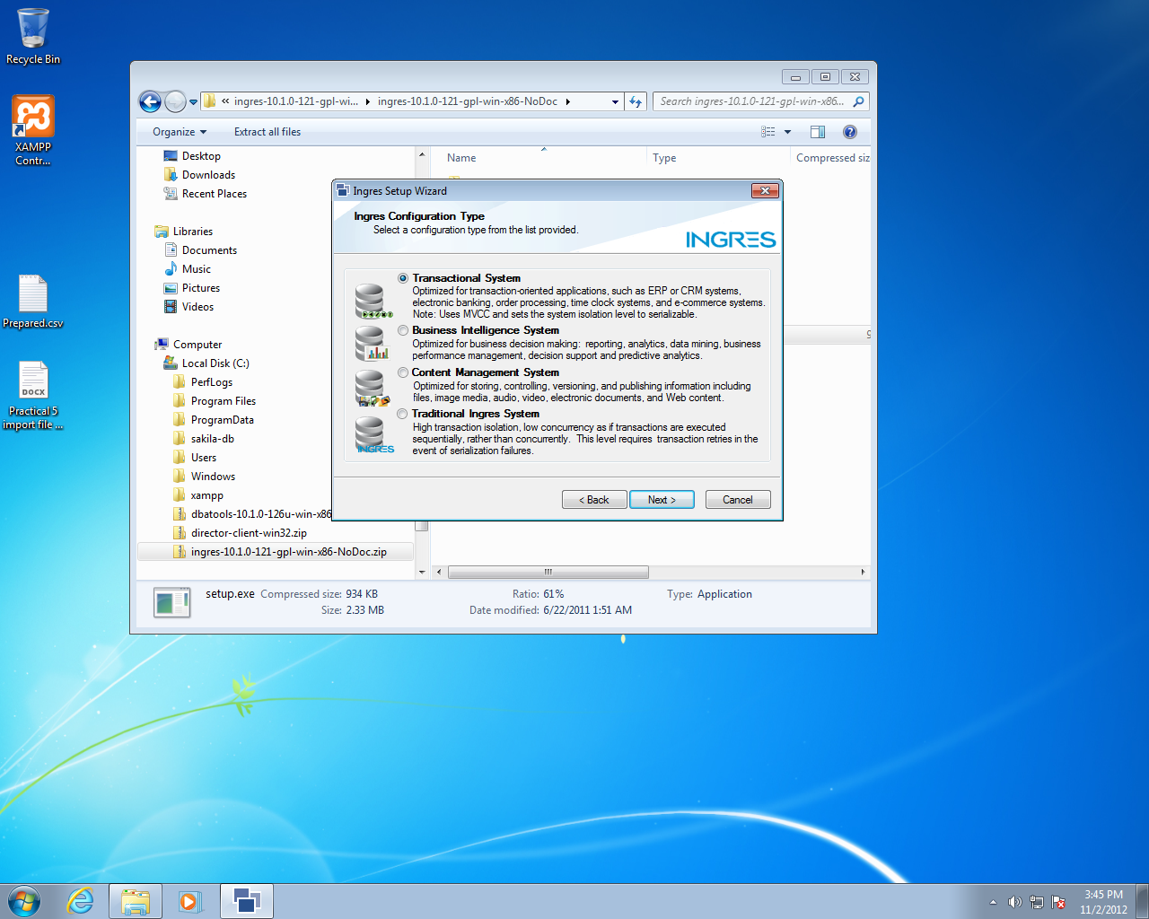

**Task: Select the Advanced option**

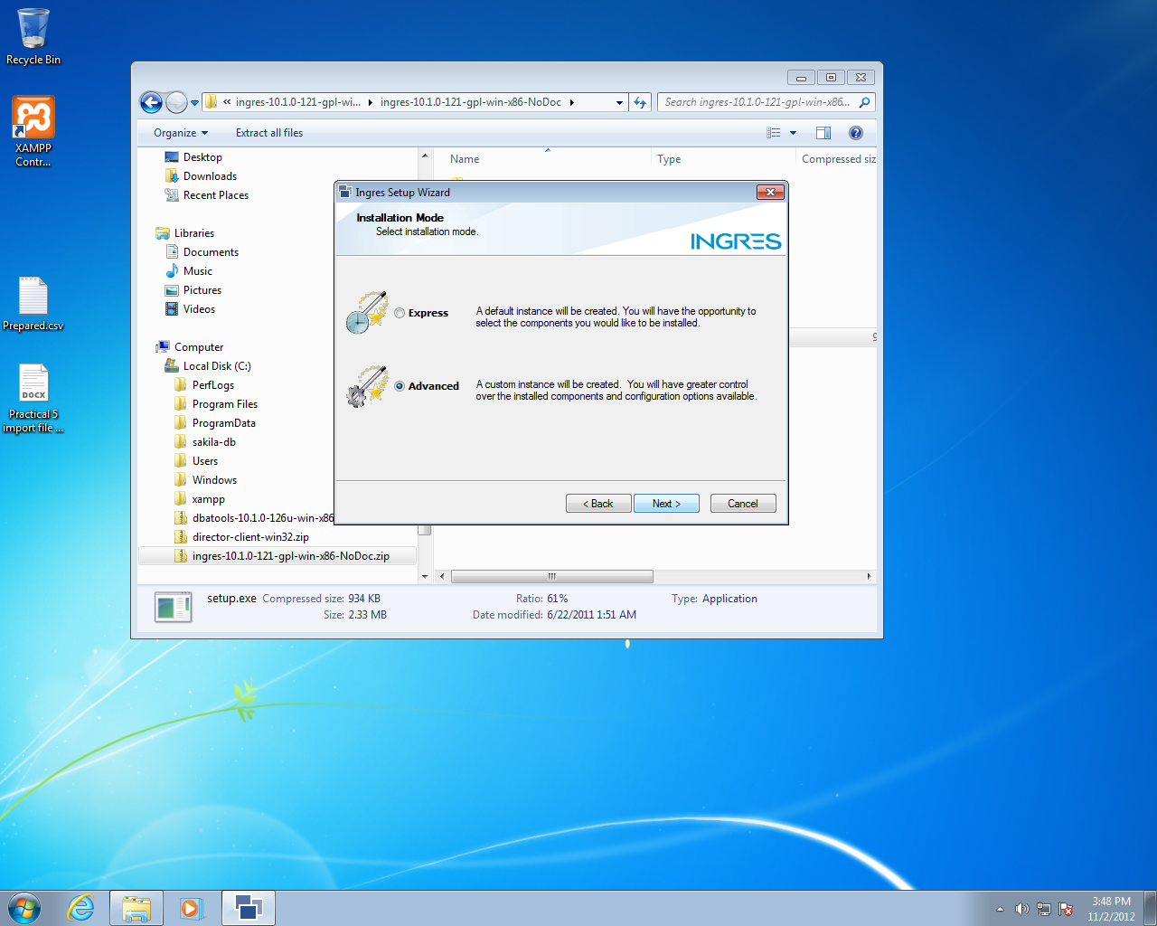

**Task: Select the default Instance name**

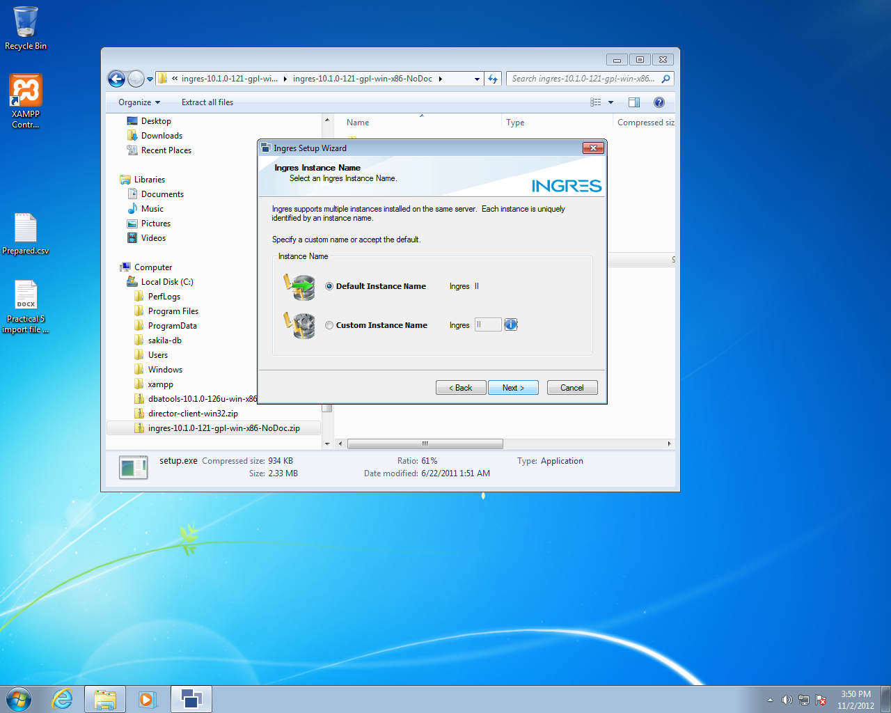

**Task: Server components: Accept the default Typical Server component list** : i.e. no replication or Star (Distributed DBMS) options

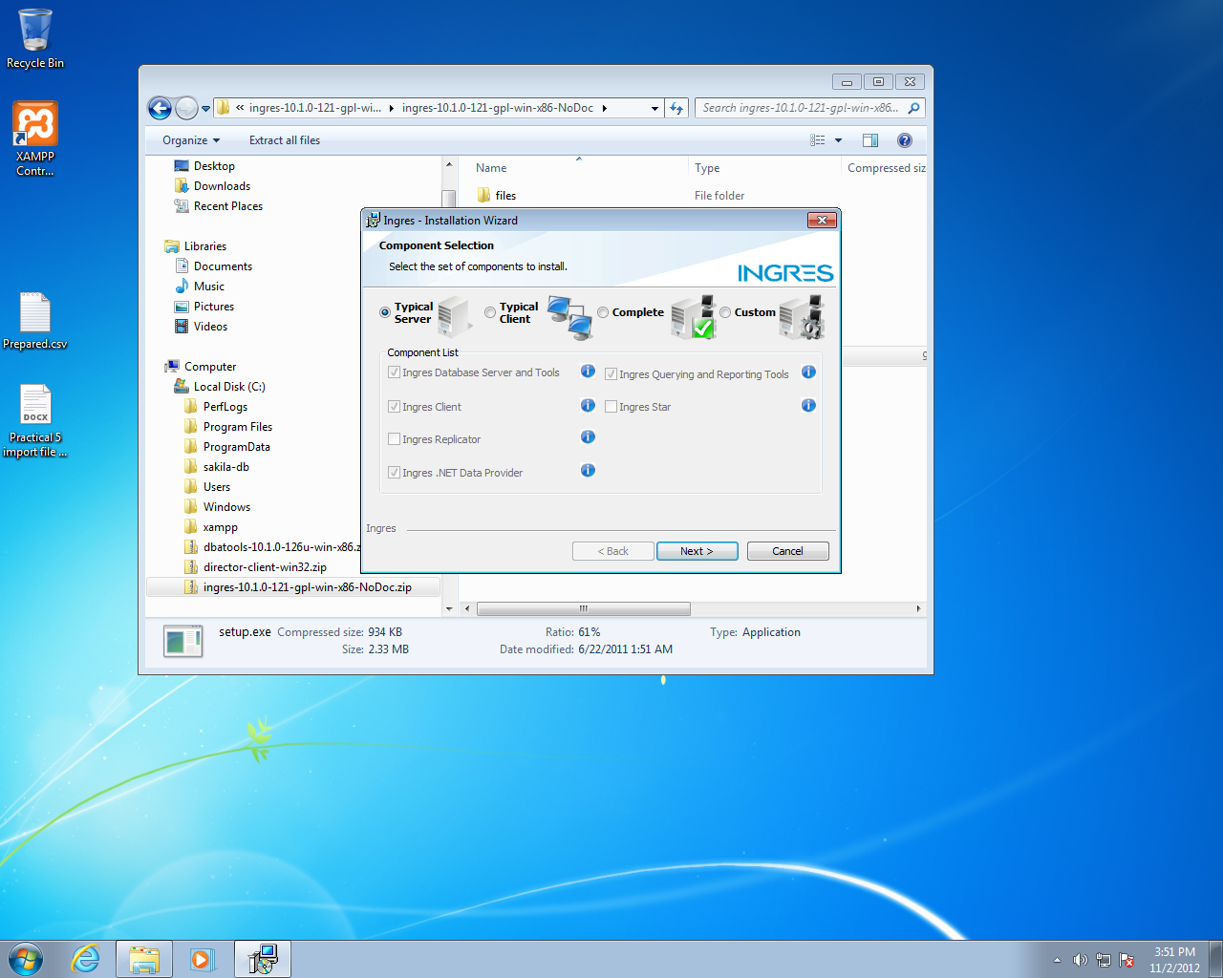

**Task: Data/Disk Management: Accept all the defaults** but note how Ingres has a number of different categories of data than MySQL, and provides easy specification of separate storage for each.

**Task: Accept the default locations, Next**

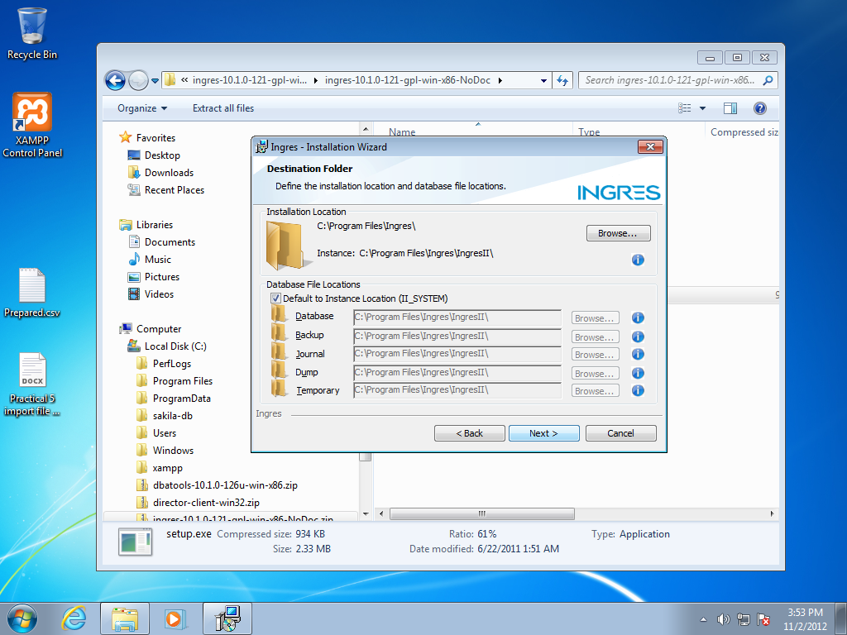

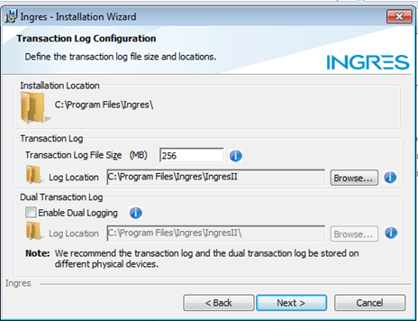

Recovery Log size and location:

Notice the difference between Ingres and MySql, where we did not set the log file size or have the option for Dual log; Note the recommendation in the screen above. A Dual Log is not a 2 log management system as in MySQL, it is a mirrored log on a separate device.

**Lab Task: Accept the default single log: Next**

**Aside: Can you compare/contrast MySQL & Ingres at this stage?**

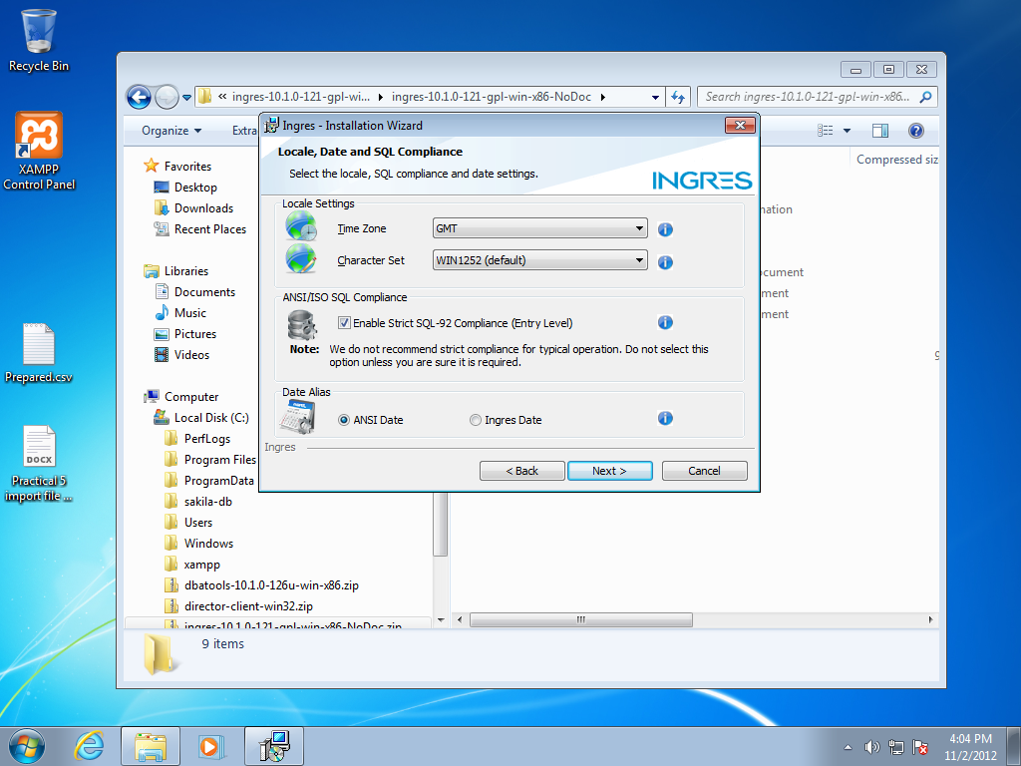

SQL and localisation setting: Time, Character set;

SQL compliance (notice more info here in the description than what was given in MySQL install).

Also notice that the Date is an issue that may need to be addressed at install & config time.

**Task: Set the SQL mode to Strict 92, accept all other defaults.**

We are installing a second full database management system on the same VM image. We will only use one at a time, therefore we will not install Ingres as a service.

**\*\*\*\*\*\*NB \*\*\*\*\*\*\*\*\*\*\***

**Task: we will UNTICK the Start Ingres Automatically option**. Therefore, to use Ingres, we will have to Start and Stop it ourselves (as the DBA).

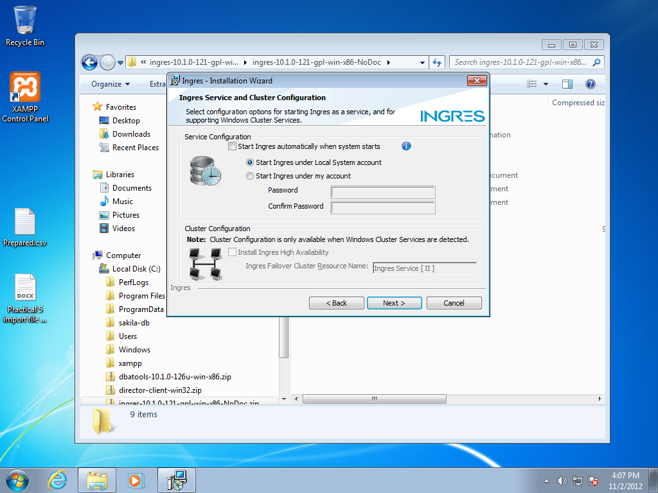

NB: **DO NOT SET any password; we will leave it blank and use the default option to Local System account**

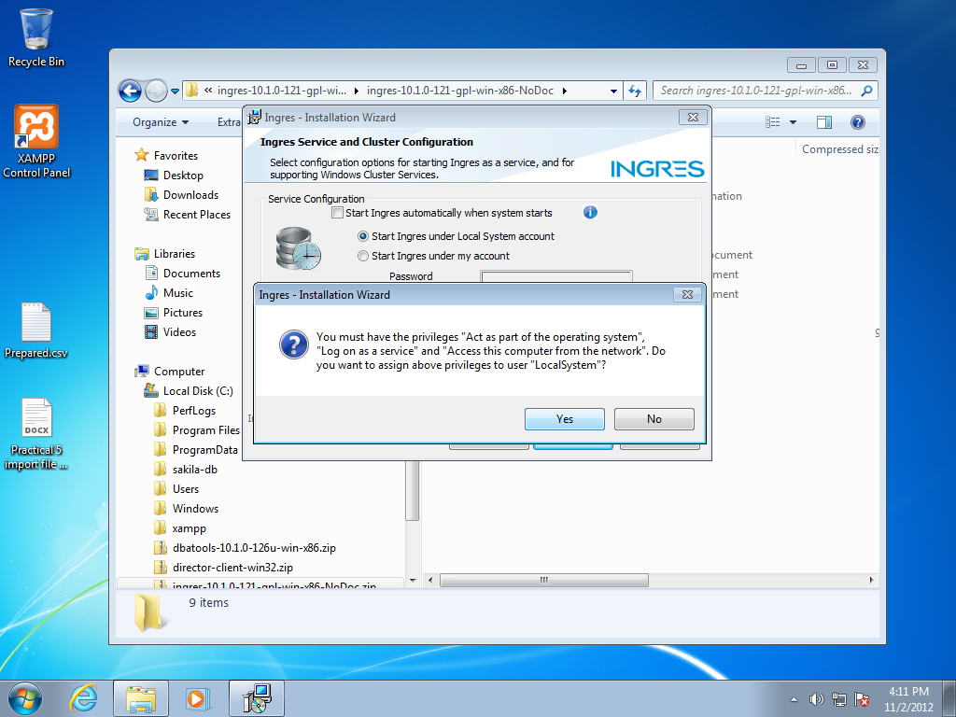

**Task: Security Privileges: select Yes to assign necessary privileges to the Local System account**.

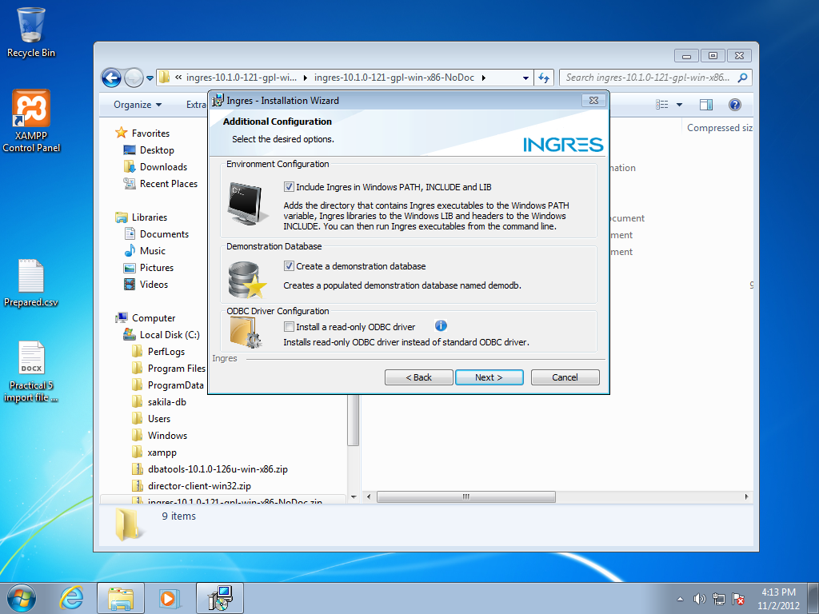

**Task: Accept the defaults for PATH, Demo database install and ODBC connector: Next**

**On the final screen, select Install**

**Task: Check install:** Use Windows – All Programs – Ingres to check if all the Ingres DBMS subsystems and utilities are installed.

In the next section, we will use the Ingres DBMS. However, that program was not installed as a service, therefore we need to investigate how to start/stop the Ingres DBMS?

**Task: investigate the Ingres installed programs for Server management utilities or use the command line looking for executable programs in the subdirectors that you installed the server into.**

We will investigate two utilities: Ingres Service Manager and Ingres Visual Manager.

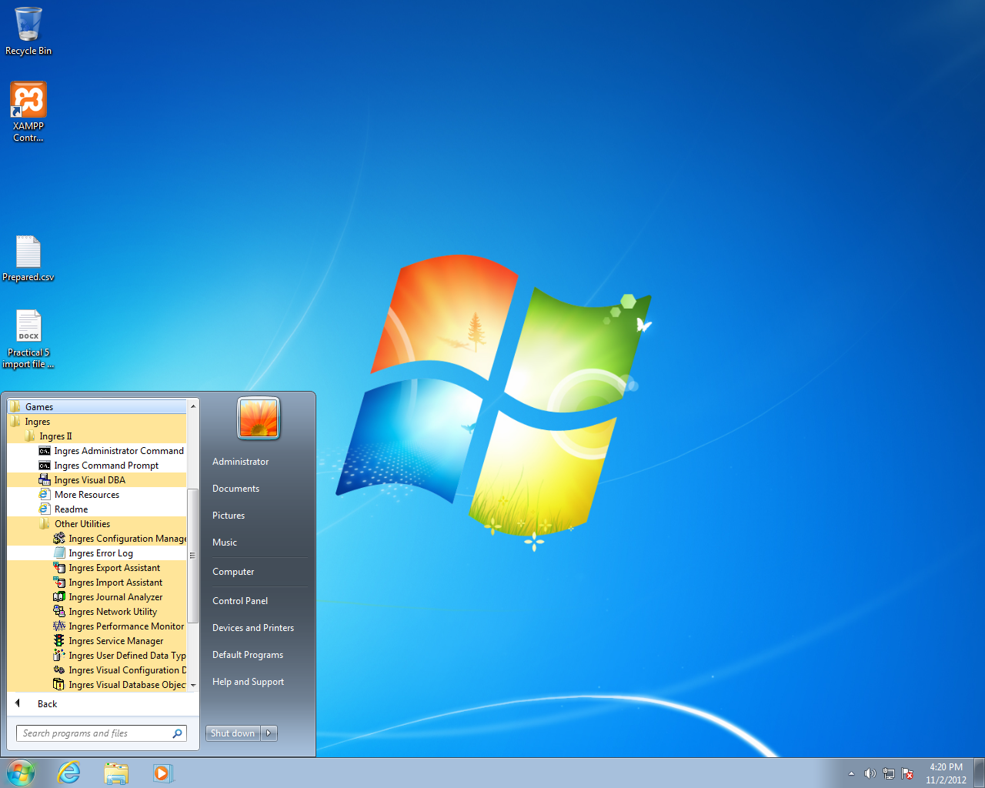

**Find and start the Ingres Visual Manager, and check the DBMS server for Stop/Start information**

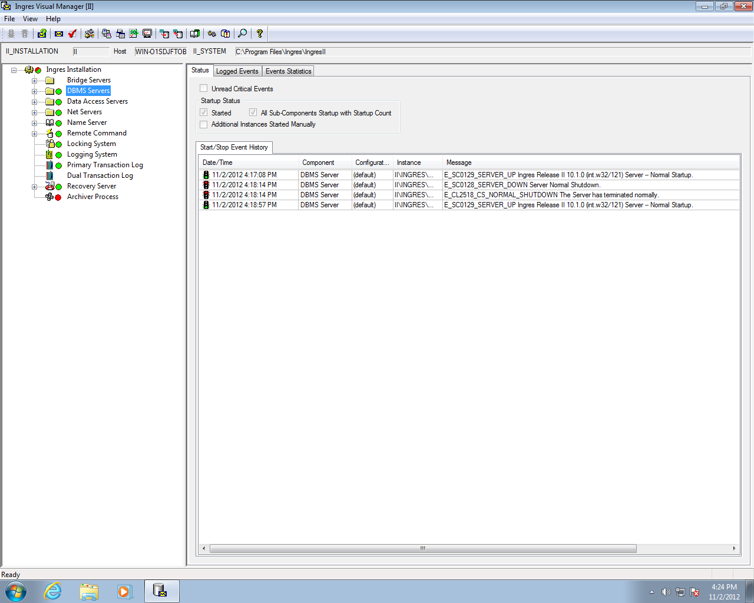

**Find and start** the Ingres Service Manager, and check the required DBMS components are running (Green). Close the Visual Service Manager program/utility (start or stop the Server as required)

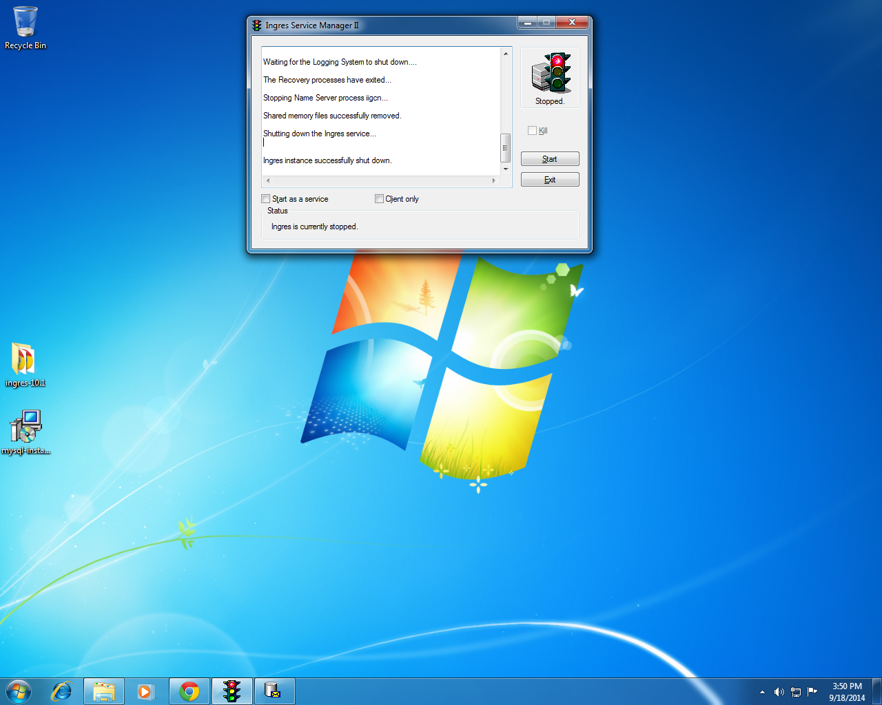

Locate and start the Ingres Visual DBA utility; Drill down in the Nodes Pane on the left hand side and highligh the Local node. Note this is like the Local Host in MySQL.

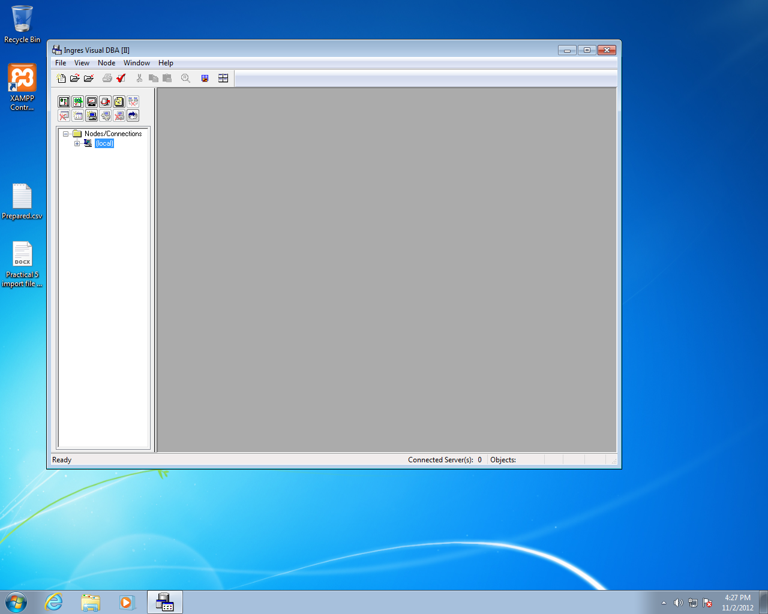

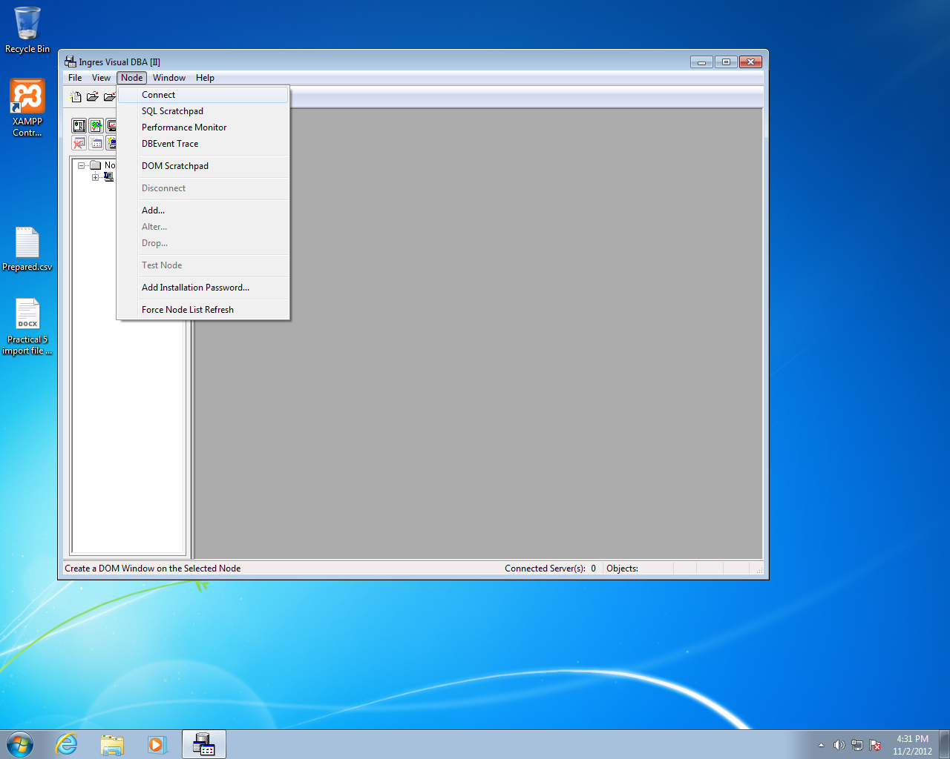

From the Node option in the Top Line menu, Select the Connect. Connect is the Administrator sub section of this utility.

Note, your options here are similar to MySQL Workbench. You can run an Admin, SQL, or other sub utility.

Ingres Visual just means that it is a Windows GUI program, with the usual point and click, right click, drill to expand/collapse, context sensitive options (i.e. highlight an object, and commands that apply to that object are made available) etc.

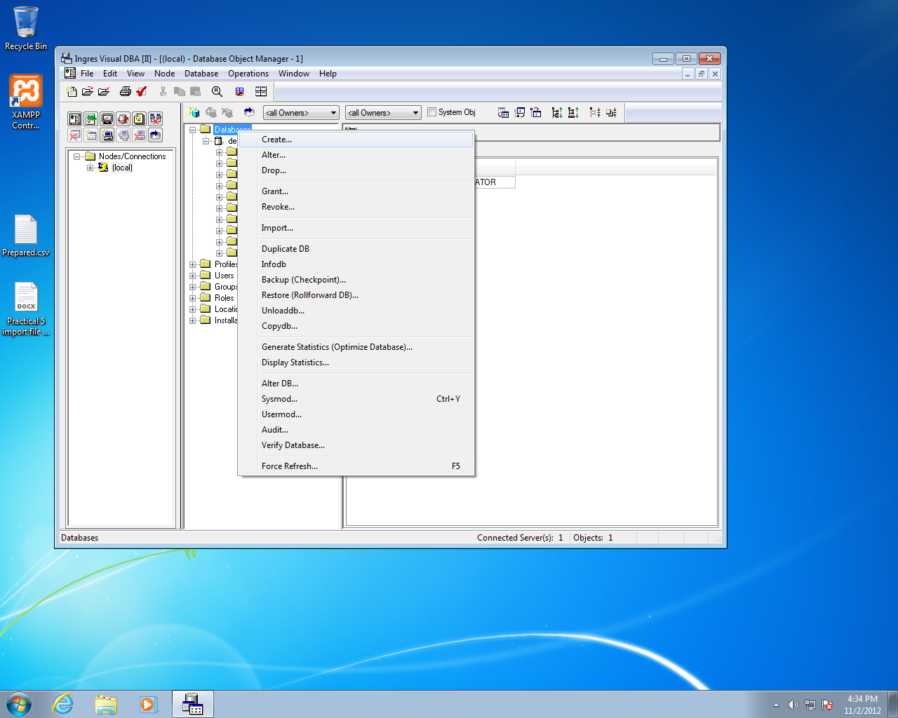

Drill down on the Database option to explore the DemoDB tables.

In this section we will use a Import utility to populate the rows in a Ingres table with data from an external data file. The data file is in a text format (comma delimited).

Point to the Database object and right click to Create a new database. Call it College.

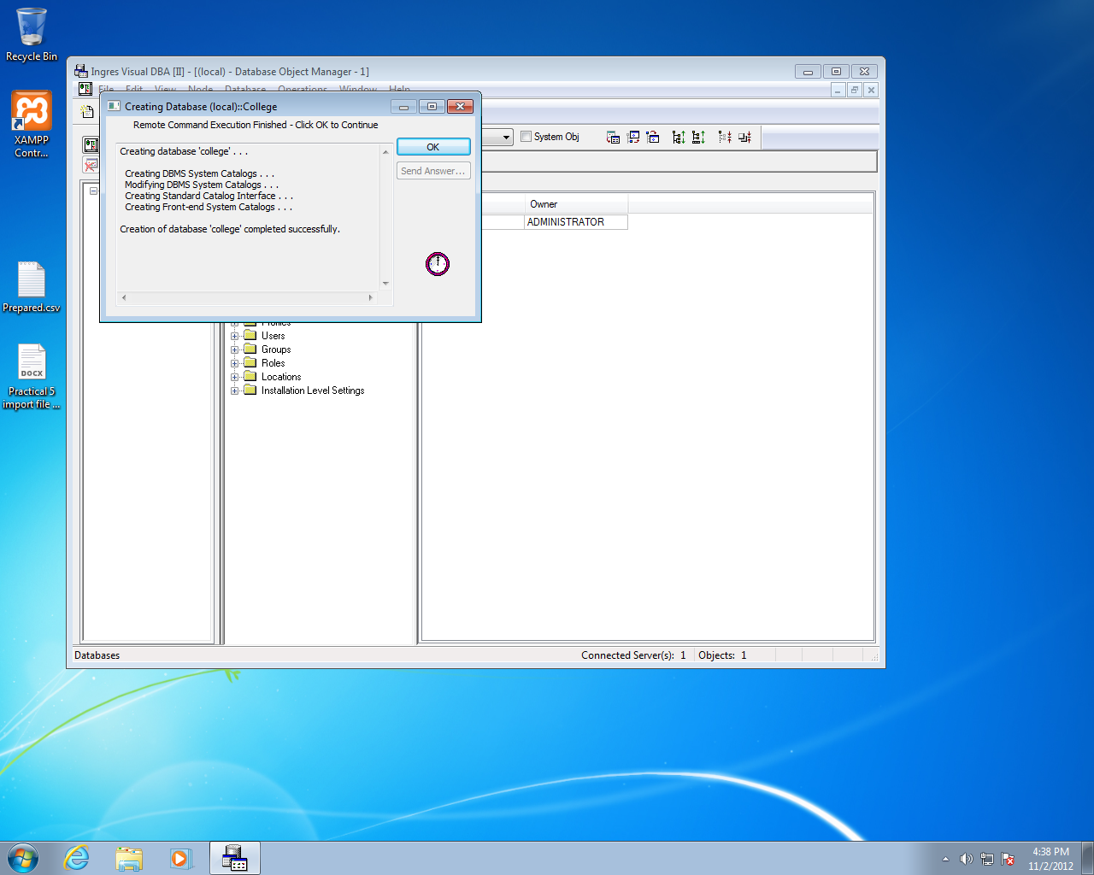

Find and start an SQL environment; create a table in the College database called Student using the same structure as you did for the file import in MySQL.

Create a table in that database called Student with the following structure. You need to know the SQL create table statement syntax.

Col name Data type

Cao_no Integer

Cit_no Integer

Dept_code Varchar(10)

Dept_name Varchar(52)

Entry_date Varchar(8)

Course_code Varchar(15)

Course_type Varchar(13)

Year Varchar(6)

Status Varchar(16)

Find and start the Ingres Import Assistant

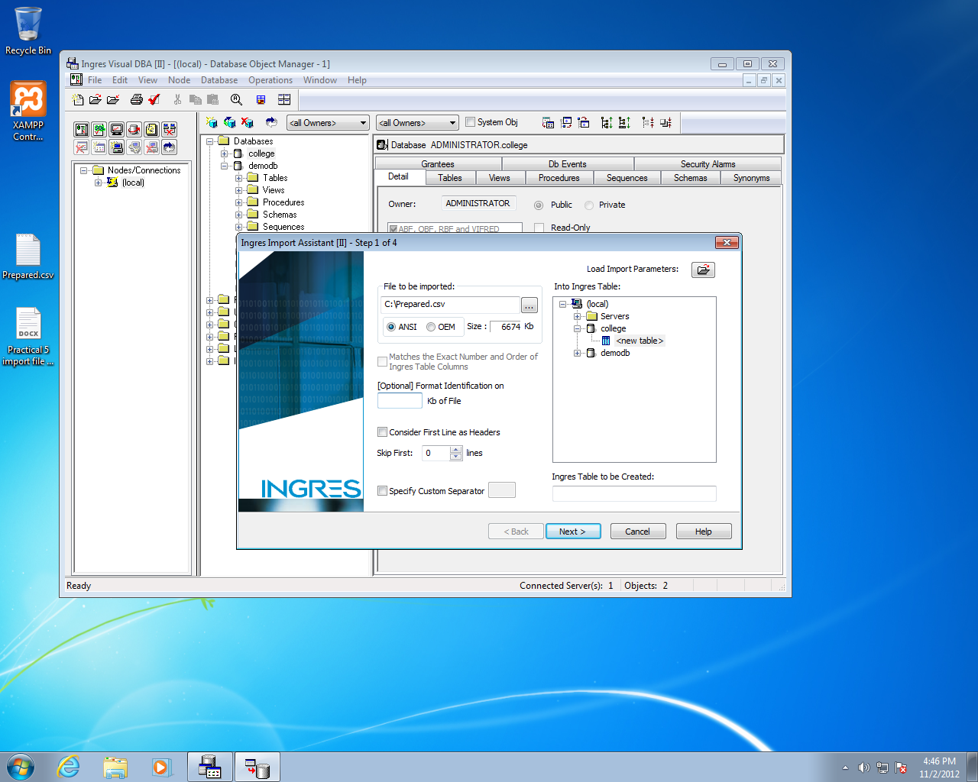

Set the values to read the Prepared.csv file into the College database, into the Student table. The Import assistant can analyse the file for formatting if you wish , and will skip any unwanted Header data if required.

Set the value of Format Identification to 10. i.e 10 kB is enough to analyse the file format.

Set the TAB that corresponds best to the format of the import file

The Import should pick up on the field definition of the target table ‘student’

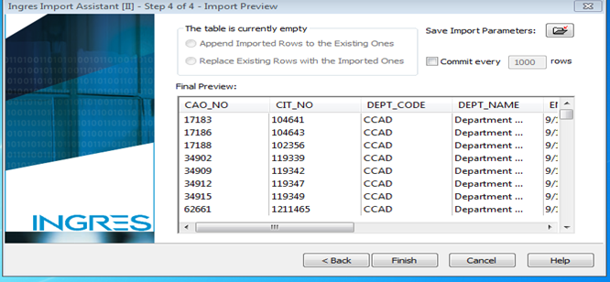

Commit after every 1000 records: this effectively divides up a large data load into smaller batches, and commits each batch as a transaction.

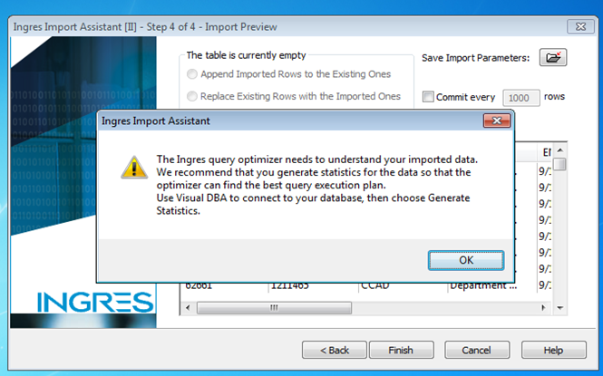

Note the message relating Statistics to Query Execution. You should also find this dealt with in the class notes (see ref Architecture & Config handout for Query Optimisation/processing).

Open an SQL session and issue

Select *

From student

Where cao_no = 5000